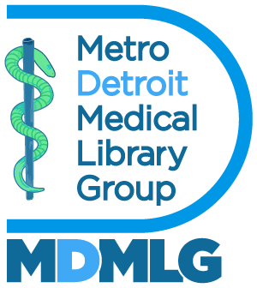

Executive Board Meeting May 3, 2023
Annual Report 2023 - 2024
Outreach – Social Media Manager

Goals and Objectives

- To bring awareness of medical librarianship particularly to student members.
- To showcase events, professional development opportunities, celebrations etc. happening within the MDMLG community.
- To speak to the benefits of joining MDMLG.

Accomplishments

Over the past year, I have reached out to students from Wayne State University and the University of Michigan as well as through SIS student groups to generate interest and student membership. Noah Greco, our new student representative will send out future promotional flyers and correspondence.

Metrics

Our Instagram account: @DetroitMedicalLibraryGroup has 44 followers and 167 posts. Our facebook group has 17 followers and 50+ posts.

Respectfully submitted,

Michelle Rau
Social Media Manager

